EXPERIMENT 4
PROBLEM:
Implement error detection and correction mechanisms using block coding and cyclic Redundancy check (CRC). Simulate a communication system in cisco Packet Tracer to demonstrate how errors are detected and corrected during data transmission .
AIM:
Error Detection and Correction Mechanism using block coding and CRC
PROCEDURE:
PART 1: Setup the Network
Step 1: Open Packet Tracer
. Launch Cisco Packet Tracer
. Go to File > New
Step 2: Add Devices to workspace
From the bottom device panel:
1. Add 2 PCs – Click “End Devices” Category – drag 2 PC icons to workspace
2. Add 1 Switch – Click “Network Devices” – “Switches” – drag 2960 switch to workspace
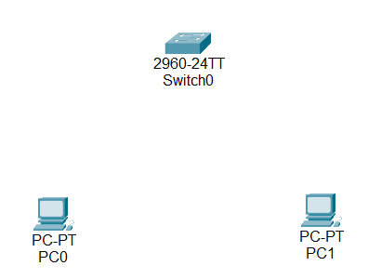
Step 3 : Connect the Devices
. Select Connections tool (lightning bolt tool)
. Choose Copper straight through cable
. Click PC0 – select FastEthernet0 port
. Click Switch – select FastEthernet0/1
. Repeat : Connect PC1 – Switch FastEthernet0/2
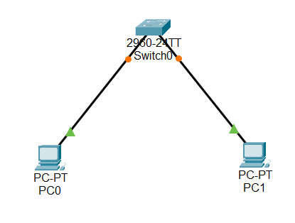
PART 2: Configure IP Addresses
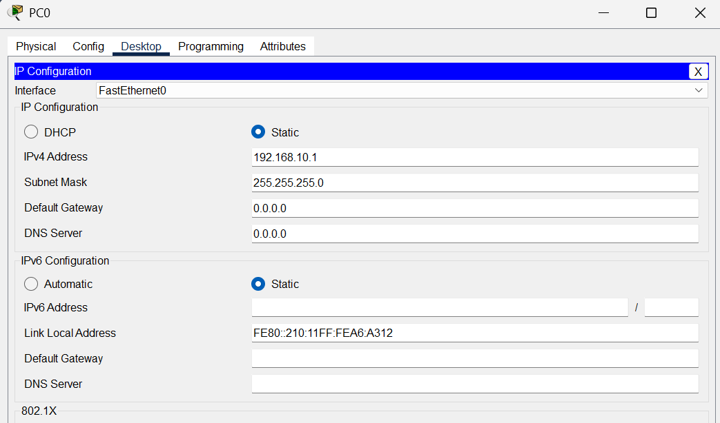
PART 3: SIMULATE DATA TRANSMISSION (Ping /PDU)
Step 7: Send the envelope icon on the toolbar – “ Add simple PDU”
Click on PC0(source)
Click PC1(destination)
You,ll see a packet animation – this simulates data transmission
Check the PDU List Window at the bottom – it should show “successful”.
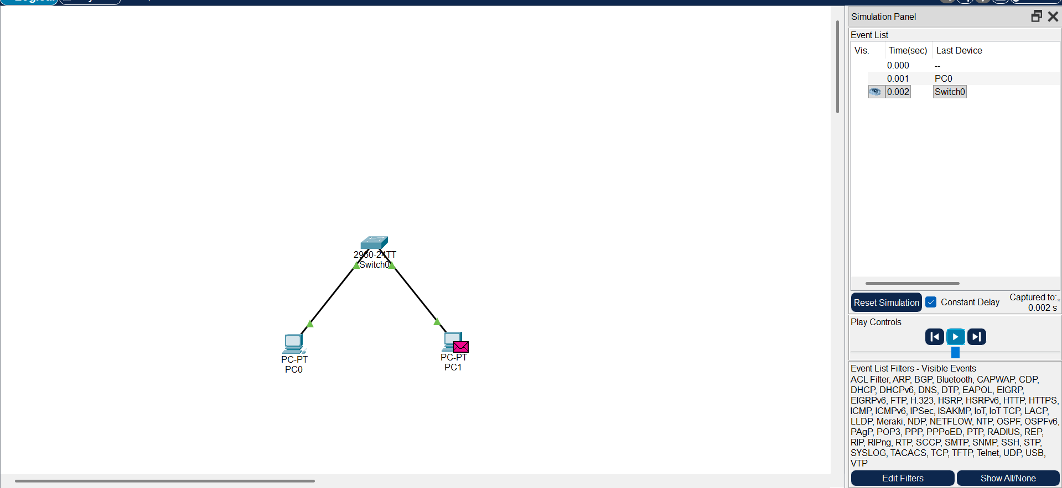
Step 8: Test Connectivity via Command Prompt
1. Click PC0 – desktop – command prompt
2. Type : ping 192.168.10.2
